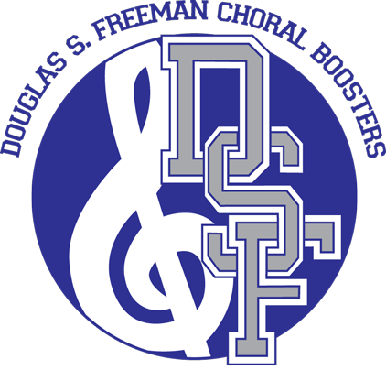

Men’s Concert Dress Requirements

September 11, 2017

Dear Parents,

The DSF Chorus Concert Season Begins in October. Your son will need to have proper concert wear for the 1st performance, which is the Fall Concert on October 8.
All boys are required to wear tuxedo pants and jacket, tux shirt (white wing collar shirt), cummerbund, bow tie, cuff links and studs along with black shoes and socks. If your son has a tuxedo, please click on the website below to confirm that your son’s tuxedo meets the above requirements as this is the required look.

If your son is new to chorus this year or he has outgrown his previous concert wear he must have a tuxedo. If a student does not have proper attire, he may not be allowed to participate in the concert and will receive a failing grade for non-participation.
High schools in our area use this online company to purchase tuxedos and this has the required tuxedo pants and jacket, shirt (white wing collar shirt), cummerbund and bow tie:

https://tuxedowholesaler.com/concert-attire/index.php/redi-ship-program/men-s-wear/poly-notch-package.html
The website provides a fitting/measurement video on the website.

You can also purchase a tuxedo at local stores such as Men’s Wear House and JoS. A. Bank.

Please let us know if you have any questions, or financial concerns please contact kmbatson@henrico.k12.va.us

Upon ordering your tuxedo, please return the below form to Mrs. Batson with evidence of your order (screen shot of confirmation, receipt, etc.). This is due on September 22, 2017.
_ _ _ _ _ _ _ _ _ _ _ _ _ _ _ _ _ _ _ _ _ _ _ _ _ _ _ _ _ _ _ _ _ _ _ _ _ _ _ _ _ _ _ _ _ _ _ _ _ _ _ _ _ _ _ _ _ _ _

Student Name: ___________________________________________ Date: _________________

___ I already own a tuxedo that meets the DSF Chorus program requirements.

___ I ordered my Tuxedo on _________ and have attached evidence of my order to this form.
(date)

Parent Name: ___________________________ Signature: ________________________________

